Data Memory
The Data Memory, RAM, is an array of 64 memory locations. Each having a 32-bit data.
Simulations for the Data Memory:
Some of the test case simulations are done using a testbench and some are done by simply forcing the values.
- To write data and read output.
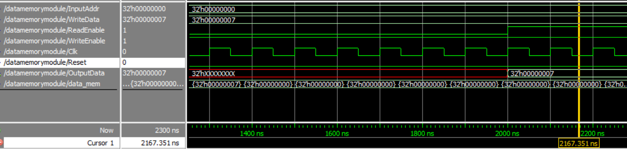
Here I want to write data to Data Memory location 32h’0, i.e. the first location. The data to be written is 32h’07.
So, first I made the read enable ‘0’ (disabled reading) and wrote the data in the memory location that we want. Then once I ran a couple of those cycles, I made read enable ‘1’ to read the output data. The output data is the data shown of the memory location where changes are made.
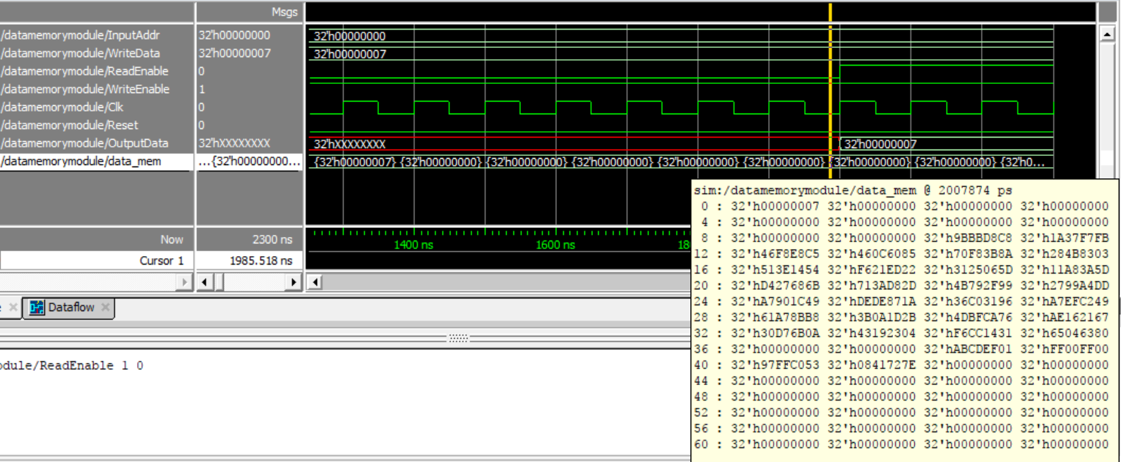
In the image above, you can see that the 0th memory location has the new data, 32h’00000007 written in it (encircled in red).
- To read data
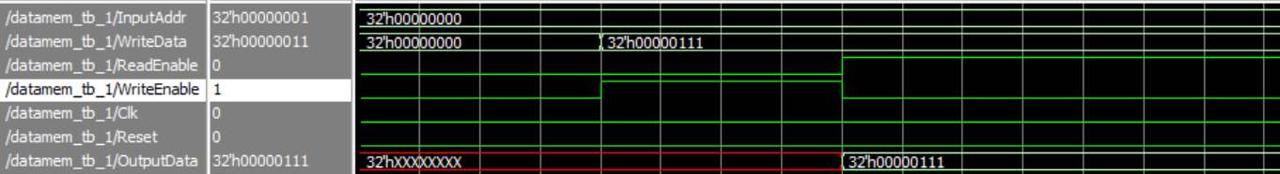
Resource Utilization:
Synthesis Stage:
Device Utilization:
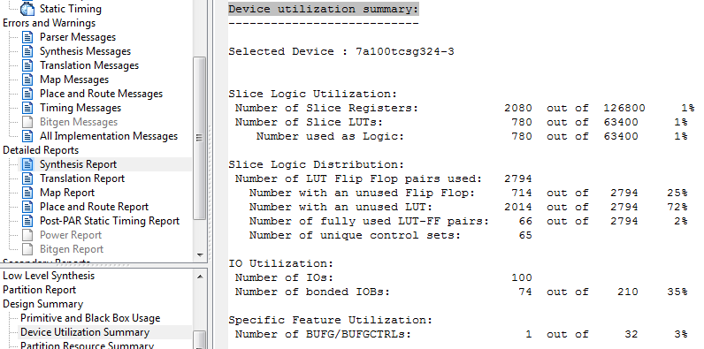
Timing Analysis:
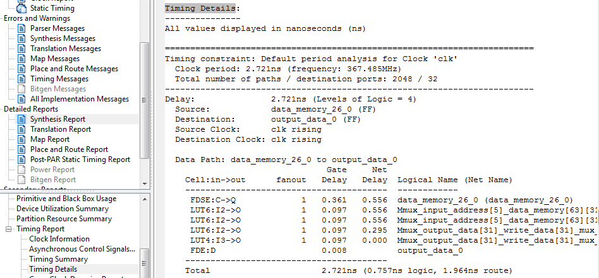

Place and Route Stage:
Device Utilization:
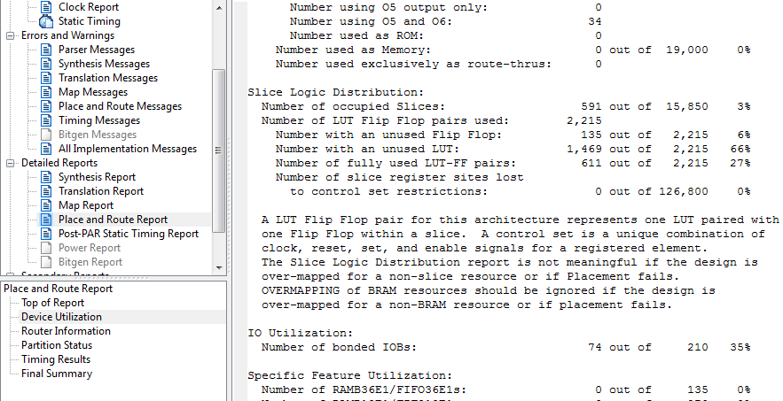
Timing Analysis:
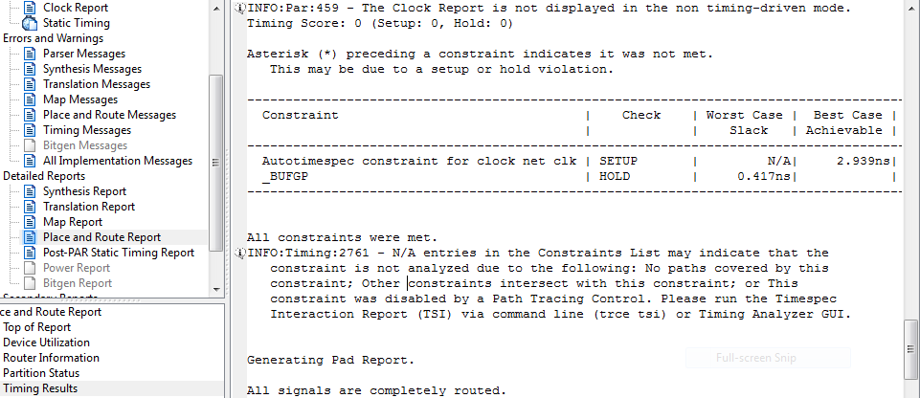

Summary of Resource Utilization in Data Memory Simulation:

 | Synthesis Stage | Place and Route Stage
Slice LUTs | 780 | 746
LUT FF pairs used | 2794 | 2215
LUT FF pairs with unused FFs | 714 | 135
LUT FF pairs with unused LUTs | 2014 | 1469
Fully used LUT-FF pairs | 66 | 611
Number of bonded IOBs | 74 | 74
Reason for the Difference | This is an estimate of the design requirements and not the actual number, so the LUTs used are more. The information here is quite limited and inaccurate. | Here, actual hardware realization is performed. This is done by modelling the circuit and then the requirements report is generated. Thus, the LUT values go down. The information given here is detailed and accurate.

